Ex3-0.sh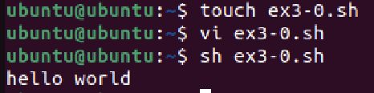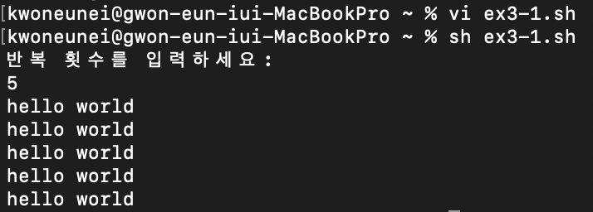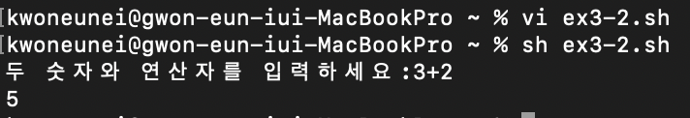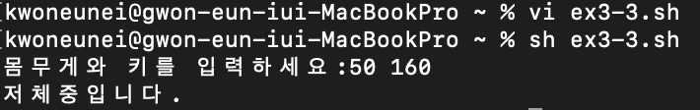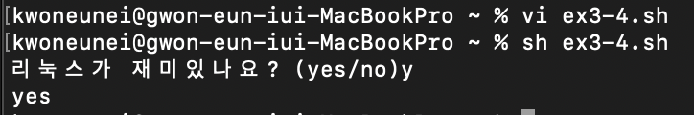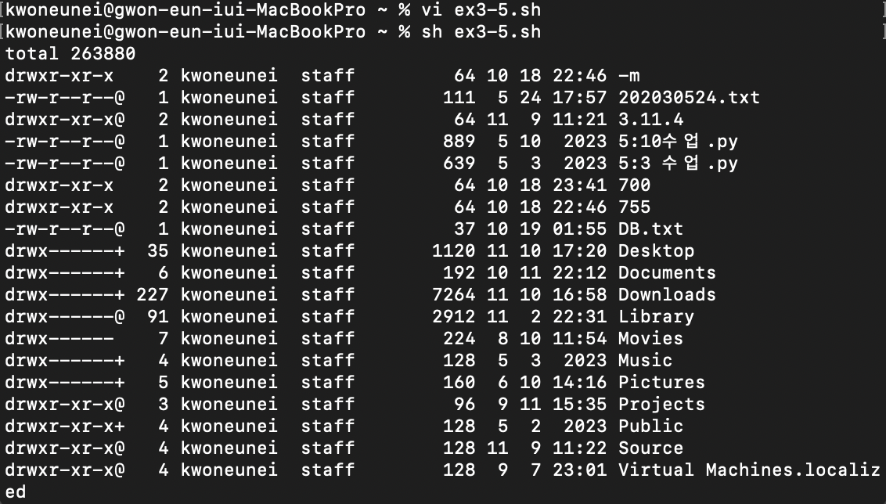

Ex3-1.sh

Ex3-2.sh

Ex3-3..sh

Ex3-4.sh

Ex3-5.sh

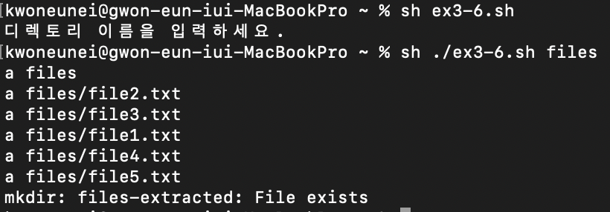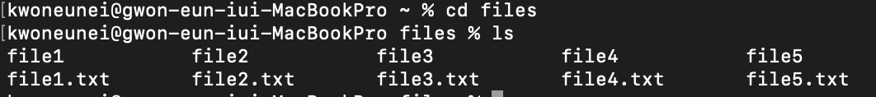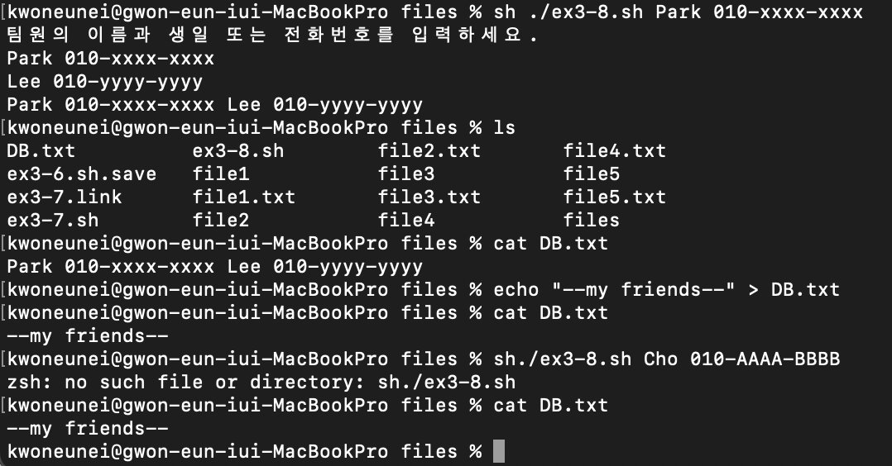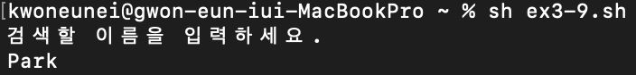스크린샷 2023-11-10 오후 5.45.21.png

Ex3-6.sh

Ex3-7.sh

Ex3-8.sh

Ex3-9.sh